LUCA Lucchina
Hourly PM_{2.5} Forecasting for Urban Air Quality: A Hybrid Transformer-LSTM Approach with MCP-Enabled Decision Support
A dissertation submitted to the degree of Master of Science
MSc Artificial Intelligence in Engineering and Design
Supervisor: Nick McCullen
09 2026



Hourly PM_{2.5} Forecasting for Urban Air Quality: A Hybrid Transformer-LSTM Approach with MCP-Enabled Decision Support
Luca Lucchina
A dissertation submitted to the degree of Master of Science
MSc Artificial Intelligence in Engineering and Design

Supervisor
Nick McCullen

The University of Bath
Department of Electronic and Electrical Engineering

Word Count (from introduction to conclusions): 9615 words

COPYRIGHT
Attention is drawn to the fact that the copyright of this thesis rests with the author. A copy of this dissertation has been supplied on condition that anyone who consults it is understood to recognise that its copyright rests with the author and that they must not copy it or use material from it except as permitted by law or with the consent of the author.

This thesis may be made available for consultation within the University Library and may be photocopied or lent to other libraries for the purposes of consultation with effect from 01/09/2026

____________________________________
Signed on behalf of the Department of Electronic and Electrical Engineering

Abstract
Urban air quality forecasting remains a critical challenge for public health management, particularly in compact valley cities like Bath, UK, where topographic trapping exacerbates wintertime PM_{2.5} accumulation. Existing systems rarely integrate multi-source environmental data into a continuous hourly forecasting pipeline and provide no automated mechanism for translating numerical predictions into actionable public health guidance.
This dissertation develops and evaluates an end-to-end PM_{2.5} forecasting and decision-support system. A hybrid Transformer-LSTM deep learning architecture is proposed, combining multi-head self-attention for long-range atmospheric pattern recognition with a recurrent LSTM layer for local sequential regularisation. Trained on nine years of hourly environmental data (January 2016 - December 2024), the Optimised Transformer-LSTM attains R² = 0.647, MAE = 2.72 μg/m³ and RMSE = 3.83 μg/m³ on an unseen, continuous January 2025 window (mean 9.33 μg/m³), reducing MAE by approximately 34% relative to a naïve seasonal baseline. This R² is comparable to the R² = 0.62 reported by Zeng et al. (2026) at daily resolution, although contextual rather than directly commensurable. Over a twelve-month window (mean 7.51 μg/m³) the multivariate variant maintains R² = 0.602, MAE = 2.31 μg/m³ and RMSE = 3.63 μg/m³. A spatio-temporal extension using graph neural network transfer learning was evaluated but produced a valid negative result: the available 9.5-month traffic dataset was insufficient to train a spatial encoder that generalised beyond its summer training window. Permutation importance analysis confirms that PM_{2.5} autocorrelation is the primary predictive signal, with wind speed and surface pressure forming a secondary tier.
The trained model is operationalised through a Model Context Protocol (MCP) pipeline, connecting a locally hosted large language model (qwen2.5:7b) to live weather and pollution APIs and model inference. This enables automated, data-grounded public health advisories rather than responses from parametric memory alone.
The study demonstrates that high-performing PM_{2.5} forecasting is achievable at hourly resolution in a UK urban setting, and that the Model Context Protocol offers a promising architectural route for bridging quantitative environmental predictions and operational decision-making. This component is presented as an exploratory proof of concept: functional and grounded in live data, but accuracy and safety of advisories have not been formally evaluated.

Acknowledgements
I would like to thank my supervisor, Dr Nick McCullen, for his guidance throughout this project. I am grateful to Bath & Northeast Somerset Council for providing access to the ANPR and traffic counter datasets, and to the Open-Meteo project for maintaining the freely available reanalysis and forecast APIs on which this work depends. I am also thankful to Luigi Pederzani from Manufact for software interface advice regarding the MCP system. Finally, I thank my family for their support throughout the thesis.

Table of Contents
COPYRIGHT 3
Abstract 4
Acknowledgements 5
List of Figures 8
List of Tables 8
List of Definitions 9
Chapter 1: Introduction 13
1.1 Problem Statement 13
1.2 Research Objectives and Approach 14
Chapter 2: Literature Review 15
2.1 PM_{2.5}, Urban Risk, and Environmental Forecasting 15
2.2 Time Series and Spatio-Temporal Forecasting Models 15
2.3 LLMs for Environmental Decision Support 16
2.4 Summary of Gaps 17
Chapter 3: Research Methods 18
3.1 Overview and System Architecture 18
3.2 Data Acquisition, Preprocessing, and Imputation 18
3.2.1 Two-Step Sequential Imputation 19
3.3 Feature Engineering and Progressive Model Development 19
3.3.1 Data Partitioning and Normalisation 19
3.3.2 Cyclic Embeddings and Predictors 20
3.4 Model Selection and Evaluation Framework 20
3.4.1 Quantitative Evaluation Metrics 21
3.4.2 The Backbone Architecture: Transformer-LSTM Hybrid 22
3.5 Spatio-Temporal Graph Model 23
3.5.1 Architecture Design 23
3.6 MCP Pipeline 24
Chapter 4: Findings / Results 25
4.1 Process Implementation and Data Pipeline 25
4.2 Quantitative Results and Architectural Comparison 26
4.3 Error Structure Analysis: MAE and RMSE Behaviour Across Architectures 28
4.4 Spatio-Temporal Transfer Learning Experimentation 29
4.5 Feature Importance Analysis 31
4.6 Multi-seasonal 12-Month Extended Evaluation 32
4.7 Comparative Benchmarking against Zeng et al. (2026) 36
4.8 Model Context Protocol (MCP) Operationalisation 37
Chapter 5: Discussion 38
5.1 Model Performance and Architectural Trade-offs 38
5.2 Physical Dynamics vs. Graph Topologies: Analysing the Spatio-Temporal model 38
5.3 Multi-Seasonal Stability and Seasonal Transition Dynamics 39
5.4 Model Context Protocol (MCP) for Operational Health Decision Support 39
5.5 Limitations of the Study 40
5.6 Practical Implications and Future Research Work 41
5.7 Ethical Considerations and System Governance 41
5.7.1 Data Governance, Legal Bases, and Privacy-Preserving Minimisation 41
5.7.2 Algorithmic Safety, Hallucination, and Unvalidated Health Advisory Risks 42
5.7.3 Operational Infrastructure: Local Inference, Data Sovereignty, and Optimisation Carbon Footprint 43
Chapter 6: Conclusions 45
6.1 Summary of the Study 45
6.2 Principal Findings 45
6.3 Contribution to Knowledge 46
6.4 Limitations 46
6.5 Recommendations and Future Work 47
6.6 Closing Statement 47
References 48
Appendices 51

List of Figures
Figure 1: Transformer LSTM model architecture design 22
Figure 2: January 2025: y_true vs transformer-LSTM predictions 27
Figure 3: January 2025 model comparison of best models (18 Jan) 28
Figure 4: January 2025 model comparison of best models (22 Jan) 29
Figure 5: PM_{2.5} distribution by month 2025 33
Figure 6: Monthly RMSE values over test set (2025) 34
Figure 7: Monthly MAE values over test set (2025) 34
Figure 8: Monthly R² score across test set (2025) 35
Figure 9: MCP Architecture and Tool Interaction 37

Figures 1 and 9 were generated using ChatGPT image generation based on prompts created by the author. All other figures were created independently by the author.

List of Tables
Table 1: Data stream characteristics and coverage 25
Table 2: Consolidated Model Performance Metrics (Test Set: January 2025) 26
Table 3: Spatio-Temporal Model Evaluation Hierarchy 30
Table 4: Feature Permutation Importance Rankings (20-Feature Space) 31
Table 5: 12 Month evaluation comparison of Univariate and Multivariate models 33
Table 6: Methodological and Performance Comparison against Target Benchmark 36

List of Definitions
Ablation Study: A test where parts of a model are deliberately removed or switched off one at a time to understand how much each part contributes to the overall performance.
ANPR (Automatic Number Plate Recognition): A camera-based system that automatically reads vehicle number plates as they pass.
ATC (Automatic Traffic Counter): A road-embedded sensor that counts the number of vehicles passing over it.
Autoregressive Time Series: A method of forecasting where future values are predicted using past values of the same variable.
Boundary-Layer Trapping: A weather phenomenon where a layer of warm air sits above cooler air near the ground, acting like a lid that stops pollutants from rising and dispersing. This causes pollution to build up at street level.
Coefficient of Determination (R²): A score with a maximum of 1.0; values below 0 indicate the model performs worse than a constant mean predictor. A score of 1.0 means perfect predictions.
Mean Absolute Error (MAE): The average size of prediction errors, ignoring whether they are over or under the actual value. An MAE of 2 μg/m³ means the model's forecasts are off by ±2 micrograms per cubic metre on average.
Root Mean Squared Error (RMSE): A measure of prediction error that penalises large mistakes more heavily than small ones. Useful for identifying whether a model occasionally makes very large errors, even if its typical error is small.
Convolutional Neural Network (CNN): A type of neural network originally designed for image recognition that detects local patterns in data. In time series forecasting, it can identify short-term repeating patterns in sequences of measurements.
DCRNN (Diffusion Convolutional Recurrent Neural Network): A neural network architecture that models how information spreads across a road network over time, combining graph-based spatial processing with recurrent sequence modelling.
Fine Particulate Matter (PM_{2.5}): Tiny airborne particles smaller than 2.5 micrometres in diameter. Because they are so small, they can pass through the nose and throat and lodge deep in the lungs or enter the bloodstream, causing serious health problems.
Graph Convolutional Network (GCN): A type of neural network that works on data arranged as a network of connected points, such as road sensors linked by roads. It allows the model to share and combine information from neighbouring sensors when making predictions.
Hyperparameter Optimisation: The process of automatically searching for the best settings for a machine learning model, such as how many layers it has or the size of said layers, by testing many combinations and keeping the one that performs best.
Imputation: The process of filling in missing data values using statistical or mathematical methods, rather than discarding incomplete records. Estimating a missing temperature reading based on the previous and subsequent hour.
K-Nearest Neighbours (KNN) Imputation: Imputing a missing value based on the most similar data points and using their values as an estimate. For example, estimating a missing temperature reading based on adjacent hours
Large Language Model (LLM): An AI system trained on vast amounts of text that can understand and generate human language. Examples include GPT-4, Llama 3, and Qwen 2.5.
Long Short-Term Memory (LSTM): A type of neural network designed to learn from sequences of data over time, with built-in mechanisms to remember important information from the past and forget irrelevant details.
MinMaxScaler: A data preparation step that rescales all input values to a standard range (typically 0 to 1) so that no single variable dominates the model simply because it has larger numbers. Applied here to ensure weather, traffic, and pollution inputs are on the same scale.
Model Context Protocol (MCP): An open standard that allows a language model to connect to and retrieve information from external tools, databases, and APIs in real time. Used here to link the forecasting model to live weather and pollution data sources.
Multi-Head Self-Attention: A mechanism inside Transformer models that allows the model to look at many different parts of a sequence simultaneously and decide which past moments are most relevant to the current prediction. Essentially lets the model learn where to focus its attention.
Optuna: An automated software tool that searches for the best configuration settings for a machine learning model by intelligently trying different combinations and learning from each attempt, rather than testing every possibility by hand.
Permutation Importance: A technique for measuring how much each input variable contributes to a model's accuracy. It works by randomly scrambling one variable at a time and measuring how much worse the model performs. (a large drop in accuracy means that variable was important)
Reanalysis Data: Historical weather and atmospheric data produced by combining past observations with computer weather models to fill in gaps and produce a complete, consistent record. Used in this study as the primary source of PM_{2.5} measurements due to its complete coverage.
Sliding Window Approach: A method of preparing time series data for a model by feeding it a fixed-length block of recent history (e.g., the past 72 hours) and asking it to predict the next block (e.g., the next 24 hours). The window then slides forward one step at a time to create many training examples.
Spatio-Temporal Graph Neural Network (ST-GNN): A neural network that processes both where something is happening (spatial) and when it is happening (temporal) by representing locations as nodes in a network. Used here to model pollution across Bath's road sensor network over time.
Temporal Fusion Transformer (TFT): An advanced forecasting model that combines attention mechanisms with the ability to handle multiple types of input variables (including static information and time-varying signals) while also indicating which variables were most influential in its predictions.
Transfer Learning: A technique where a model trained on one task or dataset is reused as a starting point for a different but related task, rather than training from scratch. Used here to apply traffic patterns learned from a short 9.5-month window to a longer forecasting model.
Univariate Forecasting: Making predictions using only the historical values of the variable being forecast, with no additional inputs. For example, predicting tomorrow's PM_{2.5} concentration using only yesterday's and today's PM_{2.5} readings.
Multivariate Forecasting: Making predictions using multiple input variables at once, rather than relying on a single measurement. For example, predicting PM_{2.5} using not just past pollution readings but also wind speed, temperature, and humidity.

Chapter 1: Introduction
Urban areas are increasingly reliant on predictive environmental monitoring to safeguard public health, manage daily municipal operations, and coordinate public events. Extreme atmospheric conditions, such as heatwaves and severe air pollution episodes, present significant risks during outdoor activities, particularly large-scale gatherings like marathons, festivals, and school programmes.
Among airborne pollutants, fine particulate matter (PM_{2.5} particles smaller than 2.5 micrometres in diameter) poses the most critical health hazard. Because of their microscopic size, these particles bypass the body's natural respiratory defences, penetrating deep into the lungs and entering the bloodstream (Clarity 2023b). This increases the potential for severe cardiovascular and respiratory illnesses. In urban environments like Bath, UK, surface PM_{2.5} levels fluctuate rapidly due to complex interactions between local vehicle emissions, weather dynamics, and daily human activity patterns.

1.1 Problem Statement
Despite advances in environmental monitoring, current urban planning tools suffer from two major disconnects:
- Firstly, municipal forecasting systems rarely combine real-time traffic dynamics, weather data, and calendar-based time patterns into a single continuous forecasting model. In urban traffic corridors, vehicle exhaust is a primary source of particulates (Carslaw and Rhys-Tyler, 2013); however, localised traffic sensor streams are rarely integrated into predictive atmospheric models due to timeline mismatches and complex spatial road networks.
- Secondly, numerical forecasts provide raw concentration values but lack context for non-expert decision-makers. While public health authorities such as the World Health Organisation (WHO) and the UK Health Security Agency (UKHSA) establish health risk thresholds, converting raw numerical predictions into actionable advice requires contextual reasoning that static number-only forecasting frameworks cannot provide.

1.2 Research Objectives and Approach
This research develops an end-to-end forecasting and decision-support pipeline:
- Multi-Modal Deep Learning Forecasting: Developing a hybrid neural network (combining Transformer with Recurrent LSTM networks) that processes historical pollution data, meteorological variables, and temporal cycles to predict hourly PM_{2.5} concentrations in Bath, UK.
- Automated Operational Decision Support: Implementing an operational pipeline using the Model Context Protocol (MCP). This framework connects a locally hosted Large Language Model (qwen2.5:7b) directly to live environmental APIs and the trained forecasting model. The LLM acts as an advisor, converting numerical pollution vectors into structured, plain-language public health advisories.
- Spatio-Temporal Graph Transfer Learning: Evaluating the predictive impact of spatial road-network topology on local air quality by integrating Spatio-Temporal Graph Neural Networks (ST-GNN) via transfer learning, isolating the marginal accuracy gain of physical transport dynamics over purely temporal baselines.

Chapter 2: Literature Review

2.1 PM_{2.5}, Urban Risk, and Environmental Forecasting
Monitoring networks in cities like Bath generate sensor readings that are often incomplete due to instrument faults or coverage gaps. Reanalysis datasets, such as those produced by Open-Meteo (2024), address this by combining historical observations with atmospheric models to produce spatially complete environmental records. This study uses reanalysis data as the primary PM_{2.5} target series to ensure consistent coverage across the full training period.
In urban environments, surface-level PM_{2.5} concentration dynamics are driven by vehicular traffic exhaust, industrial activity and broader meteorological factors such as wind velocity, ambient humidity, temperature, and planetary boundary layer stability (Kunak, 2024). As modern municipalities deploy high-density sensor networks to monitor microclimates, converting raw and continuous environmental data streams into actionable public health insights remains a persistent operational challenge (Clarity, 2023a). Accurate short-term PM_{2.5} forecasting is particularly critical for protecting public health during outdoor community events, where increased physical exertion elevates risk. While public health regulatory bodies, including the World Health Organisation (WHO, 2021), the UK Health Security Agency (UKHSA, 2023), and the UK's national air quality archive (DEFRA, 2024), provide established risk metrics and thresholds, these static exposure values require real-time contextual interpretation to support municipal decision-making.

2.2 Time Series and Spatio-Temporal Forecasting Models
The Temporal Fusion Transformer (TFT), developed by Lim et al. (2019), is a state-of-the-art architecture for multi-horizon time series forecasting. By combining multi-head self-attention with static and time-varying covariate encoders, TFT is well suited to multimodal environmental data, and its built-in variable importance mechanism makes it particularly useful for understanding the relative contribution of traffic and meteorological signals. For the specific context of this study, however, TFT's gating and enrichment layers introduce a degree of architectural complexity that is difficult to justify for single-site PM_{2.5} prediction where the primary signal is strongly autoregressive. A leaner hybrid combining a standard Transformer encoder with a recurrent LSTM layer was therefore preferred, retaining the multi-head attention mechanism for long-range pattern recognition while simplifying the remaining architecture. TFT nonetheless represents a natural candidate for future extensions involving multi-site forecasting or explicit variable importance analysis across a richer feature set.
Graph-based models represent spatial data as a network of connected nodes. In the context of traffic and air quality monitoring, each sensor location is treated as a node, and the connections between nodes represent physical road links between them. Information about pollution or vehicle counts at one node is shared with neighbouring nodes through the network structure. The Spatio-Temporal Graph Convolutional Network (STGCN, Yu et al., 2017) uses this approach to capture spatial dependencies between sensors or road segments, with evidence of improved air quality forecasting performance through the explicit modelling of spatial-temporal correlations (Panja et al., 2024). The core assumption is that geographically adjacent sensors carry correlated pollution signals, which holds in dense, multi-year sensor networks but is harder to satisfy with sparse or temporally limited traffic data, as is the case in this study.
Hybrid architectures combining TFT encoders with graph neural network spatial components have shown improved performance in recent environmental, mobility, and financial forecasting work (Rath and P, 2025; Lee and Kang, 2025; Lynch et al., 2025). These models benefit from both the long-range temporal context of attention mechanisms and the spatial structure encoded by graph convolutions, but their effectiveness is contingent on sufficient and balanced training data across both modalities. KriGNN (Ariuntugs and Maduranga, 2025) further extends this family by introducing kriging-based geostatistical priors into the graph structure, providing a principled way to handle sparse spatial sensor coverage. The relevance of these architectures to the present study lies in their assumption that spatial topology adds predictive value.
In parallel, simpler hybrid architectures combining standard Transformer encoders with recurrent LSTM layers have demonstrated competitive performance in air quality prediction tasks (Zeng et al., 2026). The primary advantage of this design is that it captures long-range atmospheric patterns through self-attention while using the LSTM's sequential inductive bias to regularise short-range transitions, resolving a known instability of pure attention models during high-amplitude pollution events. Zeng et al. (2026) report a benchmark R² of 0.62 for PM_{2.5} forecasting using such hybrid approaches, evaluated at daily resolution using seasonal evaluation blocks; this serves as the primary performance target for the present study, which operates at the more demanding hourly resolution on a continuous seasonally unfavourable test window.

2.3 LLMs for Environmental Decision Support
While numerical deep learning models project continuous pollutant concentrations, translating these outputs into clear public health advisories requires contextual reasoning that purely quantitative systems cannot provide. Large Language Models (LLMs) have demonstrated strong capabilities in domain-specific reasoning and automated text synthesis, with documented applications in clinical medical triage and climate risk summarisation. However, traditional LLM deployments suffer from parametric knowledge limits and hallucination risks when queried about real-time or rapidly changing conditions. The emergence of standardised tool-calling interfaces (MCP; Anthropic, 2024) addresses this limitation by enabling LLMs to query external APIs and local machine learning models at inference time, grounding generated responses in live data rather than static training knowledge. To date, existing literature in environmental monitoring has primarily used LLMs for static document summarisation rather than linking tool-execution pipelines directly to live, multi-horizon atmospheric forecasting backbones for event-level public health decision support.

2.4 Summary of Gaps
A systematic review of the existing literature highlights three primary research gaps that this dissertation directly addresses. Firstly, existing time series forecasting models rarely integrate localised traffic indicators and cyclic temporal signals alongside meteorological vectors in a unified continuous pipeline. Secondly, quantitative forecasting models and decision-support mechanisms are typically developed as separate, disconnected systems, leaving raw numerical outputs without automated operational interpretation. Thirdly, no operational architecture currently uses an MCP framework to ground LLMs in live environmental APIs and deep learning inference engines for event-level public health risk assessment.

Chapter 3: Research Methods

3.1 Overview and System Architecture
This study establishes a multi-stage predictive and decision-support framework to forecast hourly fine particulate matter (PM_{2.5}) concentrations in Bath, UK (51.3751°N, 2.3617°W). The methodology transitions from raw multi-source data ingestion to an automated Model Context Protocol (MCP) decision-support system.
The research design is organised across five phases:
- Data Acquisition and Preprocessing: Heterogeneous stream integration, temporal synchronisation, and two-step graph-assisted imputation.
- Feature Engineering and Model Exploration: Cyclic temporal embedding, meteorological feature construction, and progressive architecture development.
- Model Selection and Evaluation: Quantitative benchmarking across standardised statistical metrics on a continuous seasonally unfavourable test window.
- Spatio-Temporal Extension: Integration of Graph Neural Networks (GNN) to evaluate spatial road-network topology versus local atmospheric dynamics.
- Operational MCP Deployment: Integration of the optimal forecasting backbone into an MCP tool-calling pipeline for 24-hour rolling predictions and automated advisory generation.

3.2 Data Acquisition, Preprocessing, and Imputation
Predicting urban PM_{2.5} dynamics requires capturing heterogeneous environmental interactions. Multi-source data were collected at hourly intervals, comprising three primary streams:
- Air Quality Readings: Bath City Council sensors provided 1,076,416 raw 15-minute readings across five monitoring sites. Secondary pollutants such as ozone and PM₁₀ had major data gaps that made local sensor data unsuitable. The PM_{2.5} concentration target was therefore sourced from the Open-Meteo Air Quality reanalysis API, which provides complete hourly coverage for Bath from January 2014. As a counterpart this represents a spatially smoothed city-scale field rather than a street-level concentration. Meteorological covariates (Table 1) were obtained separately from the Open-Meteo Historical Weather API, selected over the UK Met Office archive (Met Office, 2024) for its consistent programmatic access to nine years of hourly historical data.
- Traffic Indicators: ANPR (~3.72M records) and ATC counters across 24 monitoring nodes, covering a 9.5-month overlap window (July 2017 - April 2018; ~6,950 hours).
All time-series sequences were aligned to a continuous UTC hourly timestamp index.

3.2.1 Two-Step Sequential Imputation
To resolve missing values without introducing temporal artefacts or synthetic bias, a two-step sequential imputation strategy was implemented:
Step 1: Graph-Based Traffic Imputation
Missing values in spatial traffic sensors were recovered using the structural topology of the underlying road network. An adjacency matrix $A∈R^{N×N}$ was constructed for N = 24 sensor nodes based on geodesic proximity within a 1km threshold, supplemented by 18 manual edges reflecting corridor connectivity. Missing sensor states were interpolated using distance-weighted spatial aggregation:
 | $${\overset{ˆ}{x}}_{i,t}=\frac{\sum_{j∈N_{i}}{w_{ij}}x_{j,t}}{\sum_{k∈N_{i}}{w_{ik}}}$$ | (1)
where $N_{i}$ denotes the spatial neighbourhood of sensor $i$, and $w_{ij}$ represents the structural edge weight inverse to geographical distance.
Step 2: K-Nearest Neighbours (KNN) Residual Imputation
For non-traffic features (PM_{2.5} and meteorological gaps) where physical network graphs do not apply. KNN imputation was performed on the temporal feature space (k = 5), estimating missing entries via distance-weighted feature averages. KNN imputation was applied exclusively to the training portion; test-set values were imputed using parameters fitted on the training set only.

3.3 Feature Engineering and Progressive Model Development

3.3.1 Data Partitioning and Normalisation
To mirror operational deployment and prevent temporal data leakage, MinMaxScaler parameters were fitted exclusively on the training split. The dataset was partitioned chronologically: training (January 2016 - December 2024) and an out-of-sample test window covering January 2025 (744 consecutive hourly timesteps). Additionally, all covariates used for multivariate inference are drawn from the 72-hour lookback window only, no future covariate values were assumed. The lookback window duration was tested from 7 days’ worth of lookback to 1 day, 72h was chosen for model training as it was the right middle ground of data richness and quick training time. January 2025 was selected as the primary evaluation window to enable direct comparison with Zeng et al. (2026), whose best-performing model was evaluated over the same calendar month. January in Bath is characterised by elevated PM_{2.5} baseline concentrations and persistent low-wind conditions, making it a stable and demanding test period. The highest atmospheric volatility in Bath occurs during spring and autumn transitions (Fan et al., 2021, Liang et al., 2022, Kaleta et al., 2023) when rapidly shifting boundary layers cause larger swings in PM_{2.5} and as temperature fluctuate, pollutant trends become more erratic. The 12-month evaluation addresses this broader seasonal range.

3.3.2 Cyclic Embeddings and Predictors
To assist neural architectures in capturing periodic multi-scale daily and seasonal dynamics, temporal timestamps were transformed into continuous cyclic features using sine and cosine functions:
 | $$t_{\text{sin}}=\sin\left(\frac{2π⋅t}{T}\right), t_{\text{cos}}=\cos\left(\frac{2π⋅t}{T}\right)$$ | (2)
where $t$ represents the temporal index and $T$ corresponds to periodicity (T = 24 for hour-of-day, T = 7 for day-of-week, T = 12 for month-of-year).
This transformation is necessary because raw integer representations (for example, hour 0 and hour 23) would appear distant to a neural network despite being adjacent in time. By encoding time as sine and cosine pairs the representation wraps around correctly, so midnight and 11pm are treated as close together.

3.4 Model Selection and Evaluation Framework
Standalone LSTM and Transformer baselines were assessed first on univariate PM_{2.5} sequences, then extended to multivariate configurations incorporating eight meteorological covariates and cyclic temporal encodings. The multivariate configuration therefore comprises 13 input channels: the eight meteorological covariates listed above, four cyclic temporal encodings (hour-of-day and month-of-year sine/cosine pairs; the day-of-week pair was excluded following backward elimination, see Section 4.5), and the autoregressive PM_{2.5} series itself. The permutation importance analysis reported in Section 4.5 was conducted on a separate, deliberately over-specified 20-channel configuration that additionally included co-pollutant series (PM10, NO2, SO2, CO), wind direction, cloud cover at mid-level, and WMO weather code, to rank a wider candidate feature set. This 20-channel model was used for feature ranking only and does not appear in Table 2.
Hyperparameter optimisation via Optuna (~40 trials per model family) was applied to the two highest-performing configurations. Model accuracy was evaluated on the final test set using three complementary statistical metrics:

3.4.1 Quantitative Evaluation Metrics
Model accuracy was evaluated on unseen test data using three standard statistical metrics:
- Coefficient of Determination (R²)
 | $$R^{2}=1-\frac{\sum_{i=1}^{n}{{\left(y_{i}-{\overset{ˆ}{y}}_{i}\right)}^{2}}}{\sum_{i=1}^{n}{{\left(y_{i}-\overline{y}\right)}^{2}}}$$ | (3)

- Mean Absolute Error (MAE)
 | $$\text{MAE}=\frac{1}{n}\sum_{i=1}^{n}{\left|y_{i}-{\overset{ˆ}{y}}_{i}\right|}$$ | (4)

- Root Mean Squared Error (RMSE)

 | $\text{RMSE}=\sqrt{\frac{1}{n}\sum_{i=1}^{n}{{\left(y_{i}-{\overset{ˆ}{y}}_{i}\right)}^{2}}}$ | (5)

3.4.2 The Backbone Architecture: Transformer-LSTM Hybrid
Across empirical evaluations, the Optimised Transformer-LSTM Hybrid [Fig. 1] achieved superior predictive accuracy.
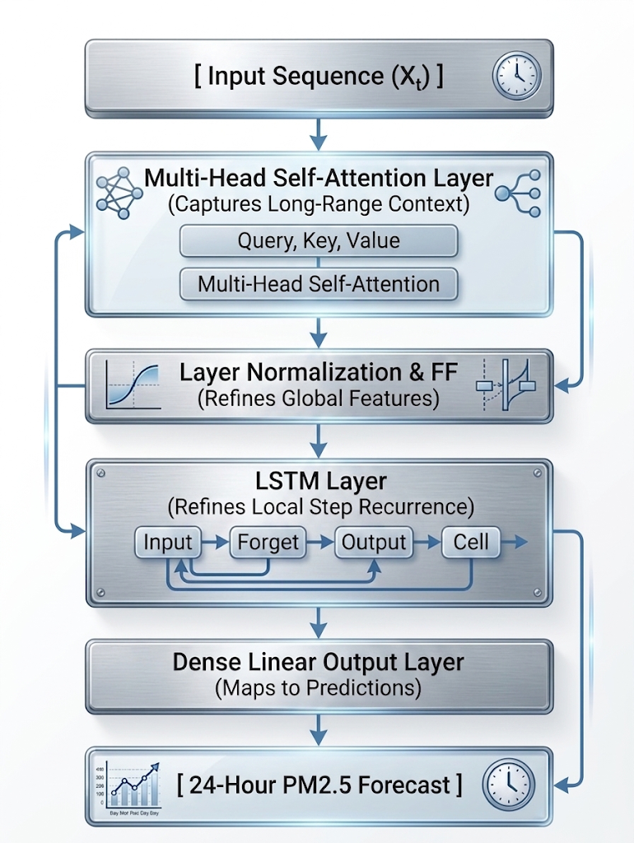
Figure 1: Transformer LSTM model architecture design
Architectural design of the Transformer-LSTM hybrid: multi-head attention layers with layer-normalised outputs feed a recurrent LSTM block, which projects onto the 24-hour forecast horizon.
The architecture employs a two-stage sequential design:
- Global Temporal Representation: the Transformer encoder allows multi-head self-attention to operate directly on the raw 72-hour input sequence without any prior compression or sequential processing. The attention mechanism treats the entire context window simultaneously, learning long-range dependencies.
- Local Recurrent Refinement: The LSTM then receives this contextualised representation rather than the raw sequence, allowing it to apply its sequential inductive bias to data that has already been globally interpreted.
Together, these two stages enable the model captures both the broad seasonal and diurnal patterns (via attention) and the smooth hour-to-hour continuity that real PM_{2.5} concentrations exhibit (via the LSTM). Reversing this order would substantially weaken both components. An LSTM operating first compresses the input into a hidden state sequentially, which by design discards information deemed less immediately relevant; the attention layer that follows would then operate on an already-degraded representation rather than the full context.

3.5 Spatio-Temporal Graph Model

3.5.1 Architecture Design
Traffic sensor data for Bath is only available for 9.5 months (July 2017 to April 2018), whereas Bath city-wide weather and PM_{2.5} data spans nine years (2016 to 2024 with 2025 as testing set). Training a single model on all three data streams simultaneously would restrict training to the 9.5-month overlap window, discarding nine years of environmental data. To resolve this, the training was separated into two stages: Stage 1 trains the spatial encoder using only the traffic overlap period, then its learned weights are frozen and transferred into Stage 2, which trains the full forecasting model on the complete nine-year record.
The optimal design would have incorporated localised weather and pollution data matched directly to each traffic sensor location, enabling a fine-grained spatial branch trained on sensor-specific conditions. This was not feasible in practice: ground-level air quality measurements at individual sensor sites were unavailable for select sensors or insufficiently consistent for the others across the 24-node network.
A two-stage spatio-temporal GNN was implemented to handle timeline mismatches:
- Stage 1 (Spatial Encoder): Graph convolutional layers (GCN) coupled with NodeLSTM encoders process traffic counts, speeds, and travel times across the 24 nodes during the 9.5-month overlap window to generate a 64-dimensional spatial embedding. The training target for Stage 1 is PM_{2.5} concentration in μg/m³, providing a supervised signal for the spatial encoder.
- Stage 2 (Temporal Fusion): The spatial encoder weights are frozen. Synthetic node features generated from full-timeline weather vectors pass through the frozen spatial encoder, and the resulting 64-d spatial vector is fused with the 128-d temporal embedding from the Transformer-LSTM backbone. City-wide reanalysis data was used instead as the input to the synthetic node feature generator.

3.6 MCP Pipeline
To operationalise the trained Transformer-LSTM forecasting model, the Optimised Transformer-LSTM Hybrid was integrated into a Model Context Protocol (MCP) decision-support architecture using FastMCP. The orchestrating language model was selected as qwen2.5:7b. This selection was governed by three practical constraints: compatibility with the Ollama local inference runtime, sufficient instruction-following capability for structured tool-calling tasks, and a parameter count suitable for CPU-accessible deployment. Among locally deployable models meeting these constraints at the time of implementation, qwen2.5:7b demonstrated the most consistent tool-invocation behaviour in preliminary testing whilst still being able to run locally in reasonable inference time. No systematic benchmark comparison across alternative models was conducted within the scope of this project. This deployment extends the system from offline model evaluation to an automated public health decision-support application.
The backend provides three primary MCP tools:
- get_weather_bath: Retrieves current surface-weather observations and 12-hour forecasts through the Open-Meteo API.
- get_pollution_bath: Queries OpenAQ for air-quality measurements.
- predict_bath_pm25_forecast: Processes the preceding 72 hours of PM_{2.5} observations, constructs cyclic temporal features, applies an online MinMaxScaler fitted to the available context window, and performs forward inference using the trained univariate transformer LSTM model. The output is a continuous 24-step hourly PM_{2.5} forecast with corresponding UTC timestamps. The MCP inference tool applies a context-window scaler rather than the training-fitted scaler; this mismatch may degrade live forecast quality, and its magnitude was not quantified.
The resulting forecasts are subsequently mapped to predefined Air Quality Index (AQI) risk categories to support interpretation of predicted exposure levels. A client application orchestrates interaction with a locally hosted qwen2.5:7b model through Ollama. For outdoor-planning queries, responses are grounded in current API observations and model-generated forecasts rather than relying solely on the language model's parametric knowledge.

Chapter 4: Findings / Results

4.1 Process Implementation and Data Pipeline
The processed dataset was partitioned using a strict temporal split to prevent data leakage. The training set spans 78,912 hourly timesteps (January 2016 through December 2024), while the out-of-sample evaluation set comprises the complete 744 hourly timesteps of January 2025.
Table 1: Data stream characteristics and coverage
Source | Data Type / Feature Space | Raw Records / Resolution | Temporal Coverage | Preprocessing & Alignment Action
Bath City Council | Ambient pollutants (PM_{2.5}, NO2, NOx, NO, CO, O3) (high missing) | 1,076,416 rows (15-min) | Aug 2014 - Present | Concatenated 5 CSVs; deduplicated; extracted coordinates; resampled to hourly index
Open-Meteo Weather API | Temperature, surface pressure, wind vectors, precipitation, humidity, cloud cover | ~97,000 rows (hourly) | Jan 2014 - Jan 2025 | Clean baseline; engineered cyclic time features (hour, day, month sin/cos pairs)
Open-Meteo Air Quality API | Target PM_{2.5} concentration (μg/m³) | ~97,000 rows (hourly) | Jan 2014 - Jan 2025 | Anchored as primary continuous target series due to complete city-wide coverage
ANPR & ATC Sensors | Vehicle counts, speeds (mph), travel times | 3.7M ANPR + ATC Excel files | Jul 2017 - Apr 2018 (~6,950 h) | Records with confidence flag=0 were discarded; aggregated to hourly per-sensor features across 24 nodes

4.2 Quantitative Results and Architectural Comparison
Model performance was evaluated on the January 2025 out-of-sample test window against a mean observed PM_{2.5} concentration of 9.33 μg/m³ (σ = 6.45 μg/m³, n = 744 hours). Model comparison demonstrates that within each model family, additional optimisation delivers consistent gains; however, architectural complexity alone does not guarantee improvement. The ST-GNN extension degraded performance due to data constraints.
Table 2: Consolidated Model Performance Metrics (Test Set: January 2025)
Model Architecture | R² Score | MAE (μg/m³) | RMSE (μg/m³) | MAE% | RMSE% | Primary Structural Characteristics
Naive seasonal model | 0.1980 | 4.15 | 5.78 | 44% | 62% | Establishes the complexity of the forecasting task as a lower-bound reference.
Darts Transformer | 0.5610 | 3.07 | 4.27 | 33% | 46% | Pure encoder-decoder self-attention over 72h context
Darts Transformer (Opt.) | 0.5980 | 2.85 | 4.09 | 31% | 44% | Tuned heads, depth, and dropout via Optuna (40 trials)
Base LSTM | 0.5916 | 2.96 | 4.12 | 32% | 44% | 2-layer recurrent baseline capturing local step transitions
Transformer-LSTM | 0.6108 | 2.86 | 4.02 | 31% | 43% | Hybrid backbone combining self-attention and LSTM
Transformer-LSTM (Opt.) | 0.6469 | 2.72 | 3.83 | 29% | 41% | Best univariate configuration; selected for MCP
Multivariate T-LSTM | 0.6219 | 2.91 | 3.96 | 31% | 42% | Expanded input (13 features) including weather drivers
ST Stage 2 (GCN Prior) | 0.5596 | 3.51 | 4.28 | 38% | 46% | Frozen GCN traffic encoder fused with temporal branch
ST Ablation (No GCN) | 0.5996 | 2.98 | 4.08 | 32% | 44% | Zero-vector substitution isolating temporal branch
Note: Percentage errors are normalised by the mean of the January 2025 evaluation window (mean = 9.33 μg/m³, σ = 6.45 μg/m³, n = 744 hours).
The Base LSTM configuration established an operational benchmark, capturing local step-by-step sequential transitions to achieve R² = 0.592, MAE = 2.96 μg/m³, and RMSE = 4.12 μg/m³. Standalone attention mechanisms evaluated via the Darts Transformer achieved a score of R² = 0.561, which improved to R² = 0.598 following Optuna hyperparameter tuning.
Combining multi-head self-attention with recurrent sequential smoothing in the Transformer-LSTM Hybrid yielded consistent performance gains over standalone baselines. The hybrid achieved R² = 0.611, while hyperparameter tuning achieved the top peak performance metrics across all model configurations on the 1-month January test window (R² = 0.647, MAE = 2.72 μg/m³, RMSE = 3.83 μg/m³).
Expanding the hybrid backbone to include eight meteorological covariates alongside cyclic temporal encodings in the Multivariate Transformer-LSTM achieved R² = 0.622. The marginal variance shift (ΔR² = -0.025 relative to the univariate optimised model) indicates that historical PM_{2.5} sequence autocorrelation implicitly absorbs a substantial portion of the atmospheric signal at hourly resolution.
Δ denotes the delta in error, difference between two R² or RMSE values
Relative to the seasonal naïve baseline, the Optimised Transformer-LSTM reduces MAE by approximately 34% (from 4.15 to 2.72 μg/m³) and raises R² from 0.198 to 0.647, establishing that the predictive gain is substantive rather than an artefact of the strong hourly autocorrelation of the target series.

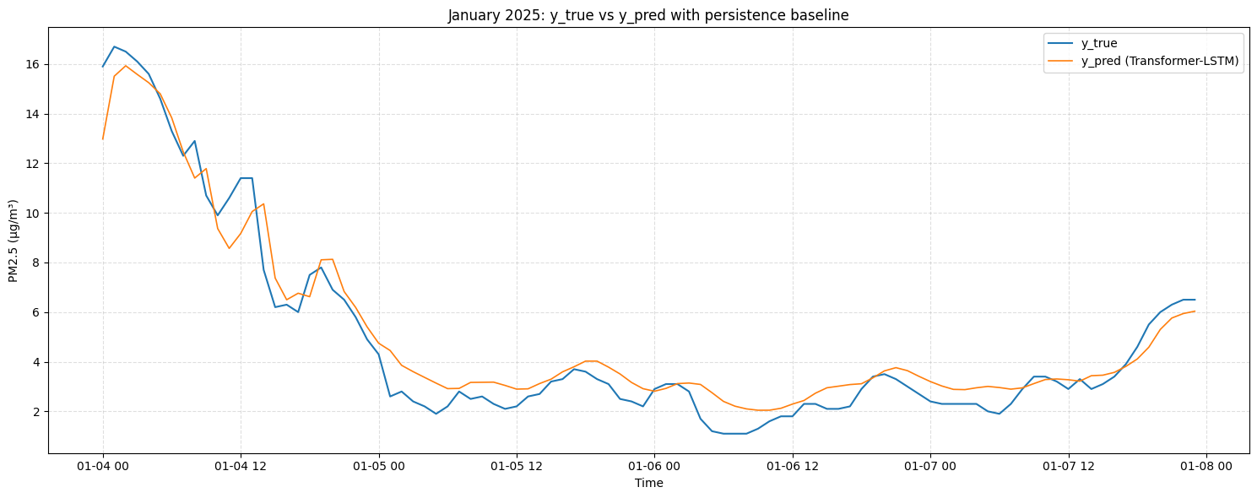
Figure 2: January 2025: y_true vs transformer-LSTM predictions
The model behaviour can be observed [Fig. 2] across a representative four-day window (4 to 8 January 2025), spanning the most pronounced inversion episode of the evaluation period. The model tracks the sharp accumulation peak of approximately 16 μg/m³ on 4 January closely, with a marginal underestimation of peak amplitude, a pattern consistent with the heteroscedastic error structure discussed in Section 4.3, whereby larger errors concentrate at high concentrations. The subsequent rapid descent through 4-5 January is reproduced with good temporal alignment, confirming that the attention mechanism captures the onset and dissipation dynamics of boundary-layer trapping events. During the low-concentration period from 5 January onwards (2-4 μg/m³), the model maintains a slight positive bias, tending to predict values approximately 1 μg/m³ above observed concentrations; this is characteristic of the LSTM's sequential smoothing, which damps abrupt transitions and introduces a small lag when concentrations fall rapidly. Overall, the figure demonstrates that the hybrid architecture reproduces both the magnitude and the temporal structure of a winter inversion cycle at hourly resolution, while the smoothed prediction trajectory reflects the stabilising effect of the recurrent layer on step-to-step forecast continuity.

4.3 Error Structure Analysis: MAE and RMSE Behaviour Across Architectures
MAE measures the average size of forecast errors across all hours, treating a 2 μg/m³ error and a 10 μg/m³ error proportionally. RMSE gives greater weight to large individual errors, meaning a model that occasionally produces very large errors will have a high RMSE even if its typical error is small. This distinction is informative here because the two metrics diverge in what they penalise rather than in which architecture they favour. Standalone Transformer models achieved MAE values of 3.07 μg/m³ (unoptimised) and 2.85 μg/m³ (optimised) on the January 2025 window, alongside RMSE of 4.27 and 4.09 μg/m³ respectively (RMSE% of 46% and 44%). Both metrics exceed those of the hybrid configurations, indicating that on a common evaluation window the hybrid provides a consistent improvement rather than an architecture-dependent MAE-RMSE trade-off.
Figures 3 and 4 illustrate the two dominant failure modes, peak underestimation and dispersal lag, that account for the elevated RMSE relative to MAE.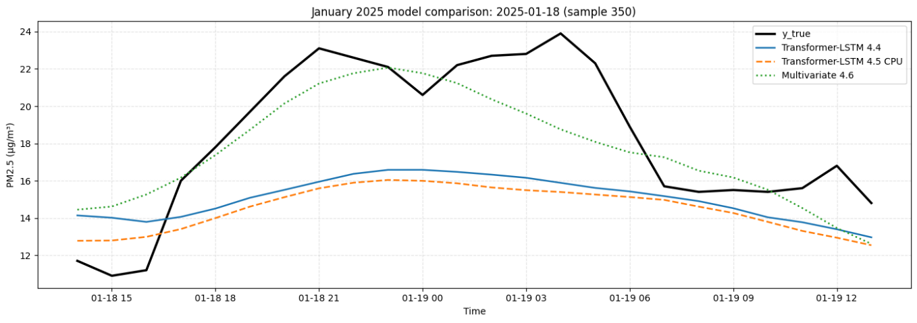
Figure 3: January 2025 model comparison of best models (18 Jan)
In the figure legends, 4.4 denotes the unoptimised Transformer-LSTM, 4.5 the optimised univariate configuration, and 4.6 the multivariate configuration, following the numbering of Table 2.
The two dominant failure modes are illustrated [Fig. 3-4], they demonstrate the error structure reported above. There is a peak seen [Fig. 3] on the 18-19 January, starting from 17:00 on the 18th to 07:00 on the 19th, in which observed PM_{2.5} reaches approximately 23 μg/m³; the univariate configurations plateau around 16-17 μg/m³, underestimating the peak by approximately 6-7 μg/m³ whilst the multivariate model performed substantially better on that midnight peak
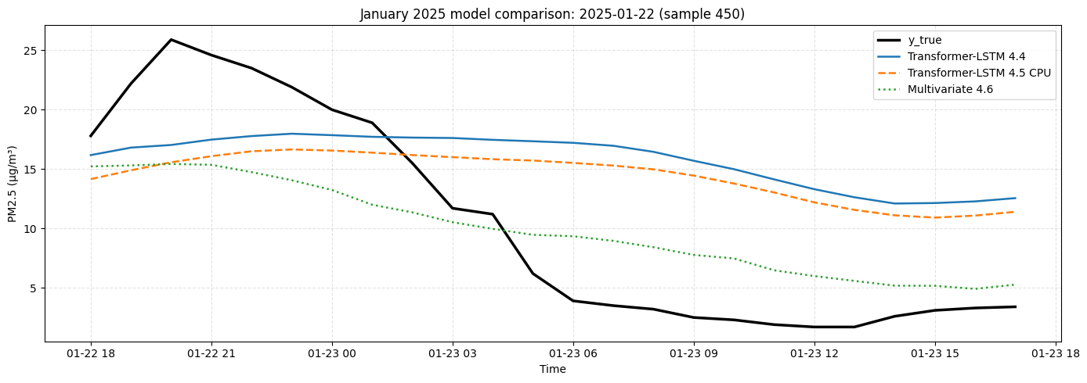
Figure 4: January 2025 model comparison of best models (22 Jan)
The inverse problem is seen [Fig. 4]: a peak on late 22nd and a crash finishing at 05:00 on the 23rd of January, in which concentrations collapse from 26 μg/m³ to below 5 μg/m³, a transition none of the configurations reproduce. Predicted values for the univariate models remain above 10 μg/m³ throughout the descent whilst the multivariate follows the downwards trend more closely, however, all three fail to match the peak early on. These failures are consistent with the smoothing effect of the LSTM layer: the recurrent stage stabilises step-to-step continuity, which benefits typical-condition forecasting but dampens the model's ability to reproduce sharp, short-lived concentration spikes or collapses. These events are individually rare but disproportionately inflate RMSE, explaining why RMSE remains higher. The practical implication for the advisory application discussed in Section 5.7.2 is that the system will tend to under-alert during acute accumulation events and under-predict the speed of recovery. The multivariate configuration partially mitigates these episodes [Fig. 3]; a fully balanced training dataset and ensemble approaches are the most direct routes to improving peak-event tracking.

4.4 Spatio-Temporal Transfer Learning Experimentation
To test whether explicit physical road topology enhances forecasting accuracy, a two-stage spatio-temporal Graph Neural Network pipeline was evaluated; results are summarised in Table 3.

Table 3: Spatio-Temporal Model Evaluation Hierarchy
Stage / Variant | Data Timeline | Evaluation Split | R² Score | MAE (μg/m³) | RMSE (μg/m³) | Structural Outcome / Diagnostic
Stage 1 (GCN) | Jul 2017 - Apr 2018 | Overlap Test (20%) | -0.2102 | 4.79 | 7.07 | Severe overfitting to summer/autumn traffic
Stage 2 (Full ST) | Jan 2016 - Jan 2025 | Jan 2025 (Out-of-Sample) | 0.5596 | 3.51 | 4.28 | Frozen spatial prior injected static noise into temporal branch (ΔR² = -0.04)
ST Ablation | Jan 2016 - Jan 2025 | Jan 2025 (Out-of-Sample) | 0.5996 | 2.98 | 4.08 | Confirmed temporal backbone integrity in isolation
In Stage 1, a GCN-NodeLSTM spatial encoder was trained on the traffic overlap window (July 2017 to April 2018). The model overfit the training distribution, with training MSE falling to 0.004 while validation MSE plateaued at ~0.009. When evaluated on the out-of-sample traffic split, Stage 1 achieved R² = -0.210 (MAE = 4.79 μg/m³), indicating that the model failed to generalise beyond its summer/autumn training window.
In Stage 2, the spatial encoder weights were frozen, and its 64-dimensional spatial embedding vector was fused with the 128-dimensional temporal embedding from the Transformer-LSTM backbone. Evaluated on the January 2025 test window, Stage 2 achieved R² = 0.559 (MAE = 3.51 μg/m³, RMSE = 4.28 μg/m³).
An ablation experiment was conducted wherein the 64-dimensional spatial vector was replaced with a zero vector, isolating the temporal branch. The ablation model achieved R² = 0.599 (MAE = 2.98 μg/m³, RMSE = 4.08 μg/m³). Fusing the frozen spatial prior degraded predictive performance by ΔR² = -0.040. Diagnostic analysis indicates that freezing a spatial encoder trained on seasonally skewed, summer-dominated traffic data injected static noise into the temporal backbone during peak winter conditions.

4.5 Feature Importance Analysis
Permutation importance measures how much a model's accuracy drops when the values of a single input feature are randomly shuffled, breaking any real relationship between that feature and the target. A large drop in accuracy after shuffling indicates the model was relying heavily on that feature; a small drop suggests the feature contributes little. This analysis was conducted across an expanded 20-feature dataset to identify which inputs the model depends on most.
Table 4: Feature Permutation Importance Rankings (20-Feature Space)
Feature Name | Feature Description / Physical Category | Δ MAE (μg/m³) | Δ R² Score | Importance Tier
pm2_5 | Autoregressive historical PM_{2.5} concentration | 0.36 | 0.13 | Tier 1 (Primary Autoregressive Driver)
Wind speed | Upper-level wind speed (100m dispersion vector) | 0.28 | 0.082 | Tier 2 (Primary Atmospheric Dispersion)
pm10 | Coarse particulate matter concentration | 0.26 | 0.090 | Tier 2 (Co-pollutant Signal)
wind_speed_10m | Surface wind speed (10m local dispersion) | 0.16 | 0.036 | Tier 2 (Local Boundary Transport)
Sulphur dioxide | Background SO2 concentration | 0.12 | 0.049 | Tier 3 (Secondary Emissions Indicator)
Carbon monoxide | Background CO concentration | 0.11 | 0.019 | Tier 3 (Combustion Proxy)
Wind direction | Transport direction vector (100m) | 0.099 | 0.030 | Tier 3 (Directional Advection)
Nitrogen dioxide | NO2 combustion/traffic proxy | 0.090 | 0.040 | Tier 3 (Local Mobile Source Indicator)
Surface pressure | Synoptic surface pressure (stagnation proxy) | 0.082 | 0.025 | Tier 3 (Boundary-Layer Stability)

Features are ranked by ΔMAE. The ordering by ΔR² differs slightly for closely ranked features (pm10 ΔR² = 0.090 > wind_speed_100m ΔR² = 0.082). As wind_speed_10m and wind_speed_100m are strongly correlated, permuting either in isolation understates its importance. Δ values denote degradation magnitude.
Autoregressive historical PM_{2.5} concentration emerged as the primary predictive feature, yielding the largest error increase when permuted (ΔMAE = +0.36 μg/m³, ΔR² = +0.13). Meteorological features associated with particulate dispersion and atmospheric stability constituted the secondary tier of importance. Upper-level wind speed (wind_speed_100m) ranked second (ΔMAE = +0.28 μg/m³), followed by PM₁₀ (ΔMAE = +0.26 μg/m³), surface wind speed (wind_speed_10m: ΔMAE = +0.16 μg/m³), and surface pressure (ΔMAE = +0.082 μg/m³). Backward elimination confirmed that cyclic temporal features such as hour_cos provided redundant information when explicit historical sequences were present.

4.6 Multi-seasonal 12-Month Extended Evaluation
The primary evaluation framework for this study uses January 2025 as a test window. While this window provides an evaluation of model performance under winter conditions (to compare with Zeng et al 2026), it represents only one seasonal regime and cannot, by itself, establish whether the model maintains predictive stability across the full annual cycle. To assess multi-seasonal robustness, the best models were subjected to an extended evaluation spanning a complete 12-month cycle. Those were the optimised Darts model (as well as the unoptimized version) which performed at 0.598 R² over the 1-month evaluation, the univariate model which performed at 0.647 R² score and the multivariate model which performed at 0.622 R² score. The 12-month evaluation is intended to characterise seasonal generalisation behaviour, not to supersede the primary model comparison; results should be interpreted accordingly alongside Table 2.
While a winter window evaluates accuracy under high background pollution loading, a full-year evaluation tests stability across the spring and autumn transitions, where atmospheric volatility is highest.
During these transitional seasons, shifting synoptic wind patterns and fluctuating planetary boundary layer heights induce rapid, high-frequency oscillations between sudden pollutant accumulation and atmospheric dispersion. Across the full 12-month cycle, the Multivariate Transformer-LSTM maintained a global R² of 0.602 and reduced mean absolute error to MAE = 2.31 μg/m³. The extended evaluation covers calendar year 2025 (8,760 hourly timesteps, January 2025 – December 2025), for which the mean observed concentration is 7.51 μg/m³ (σ = 5.76 μg/m³). The lower absolute MAE and RMSE relative to January therefore reflect this reduced baseline rather than improved accuracy; percentage errors in Table 5 are normalised by this annual mean.

Table 5: 12 Month evaluation comparison of Univariate and Multivariate models
Model Variant | Evaluation Window | R² Score | MAE (μg/m³) | RMSE (μg/m³) | MAE% | RMSE%
Darts Transformer | 12 Months | 0.5526 | 2.44 | 3.85 | 33% | 51%
Darts Transformer (Opt.) | 12 Months | 0.5887 | 2.44 | 3.70 | 33% | 49%
Transformer-LSTM (Opt.) | 12 Months | 0.5965 | 2.37 | 3.65 | 32% | 49%
Multivariate Transformer-LSTM | 12 Months | 0.6023 | 2.31 | 3.63 | 31% | 48%

The seasonal variation in absolute error is directly attributable to the variation in background PM_{2.5} concentrations across the annual cycle [Fig. 5]. Winter and early spring months (January-April) exhibit both elevated medians (8-12 μg/m³) and wide interquartile ranges, with March recording extreme outliers exceeding 40 μg/m³ under prolonged anticyclonic conditions. Summer months (June-August) showed compressed distributions with medians below 5 μg/m³ and minimal spread. The low variance in July directly explains why R² becomes an unstable metric in that month, as the denominator of the coefficient approaches zero. The episodic outliers visible in October-December, despite low medians, reflect short-lived inversion events during the autumn transition and account for the asymmetric error patterns discussed in Section 4.3.
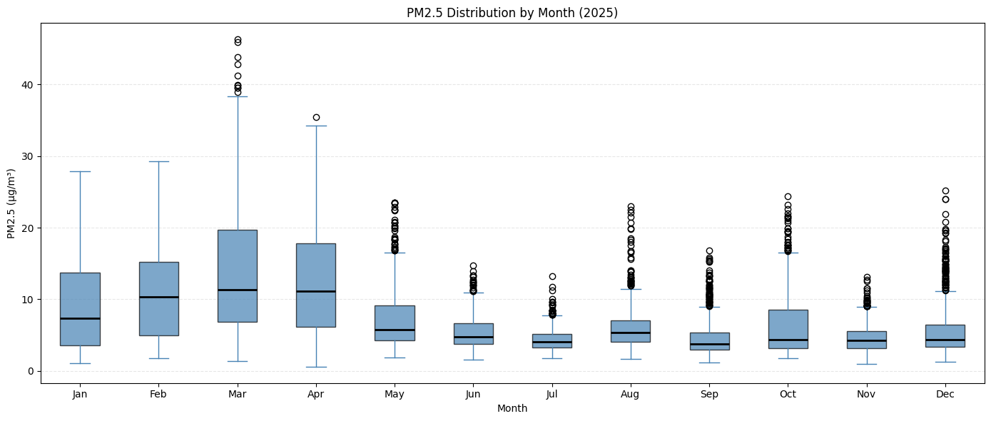
Figure 5: PM_{2.5} distribution by month 2025

The extended evaluation covers calendar year 2025 (8,760 hourly timesteps, January 2025 - December 2025).
In further details, monthly evaluations were made for RMSE, MAE and R² [Fig. 6-7-8].
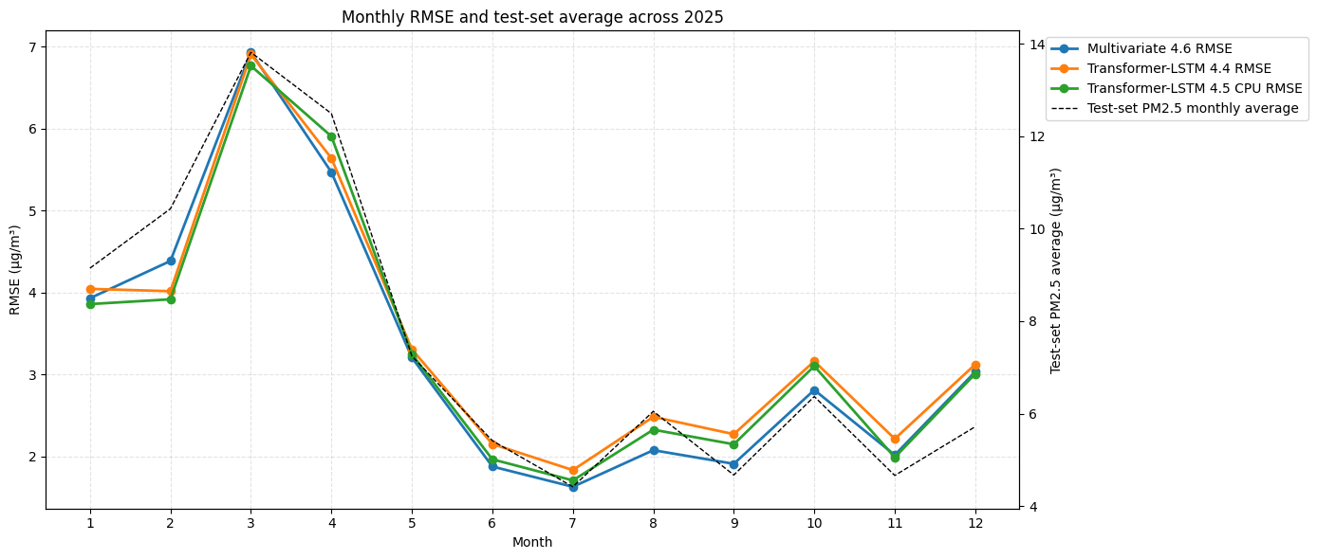
Figure 6: Monthly RMSE values over test set (2025)
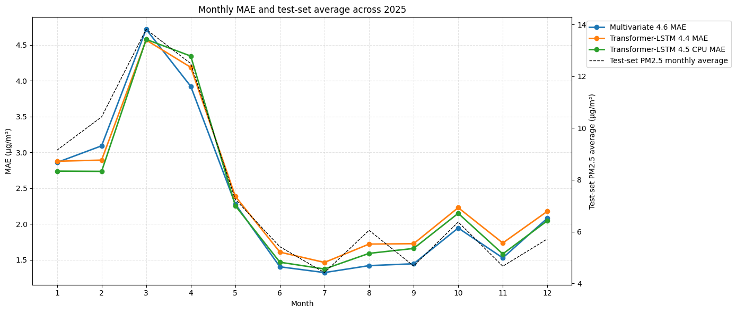
Figure 7: Monthly MAE values over test set (2025)
The monthly evaluation metrics for 2025 demonstrate strong alignment between error magnitude and ambient background PM_{2.5} concentrations, as illustrated by the RMSE [Fig. 6] and MAE [Fig. 7] trajectories. Both error metrics closely mirror the overall concentration profile, reaching their peak during March (where test-set monthly averages approach 14 μg/m³) with maximum RMSE and MAE values of approximately 6.8-7.0 μg/m³ and 4.6-4.7 μg/m³, respectively. Conversely, as seasonal background concentrations drop during the summer months (Months 6-8), both error metrics decline significantly to minimums around 1.3-2.1 μg/m³. Across the entire 12-month period, the Multivariate 4.6 model consistently outperforms or matches the univariate baseline variants (Transformer-LSTM 4.4 and Transformer-LSTM 4.5), achieving lower MAE and RMSE during both peak pollution events and summer lows, notably in April, August, September and October where the inclusion of external meteorological features delivers a distinct reduction in prediction error.

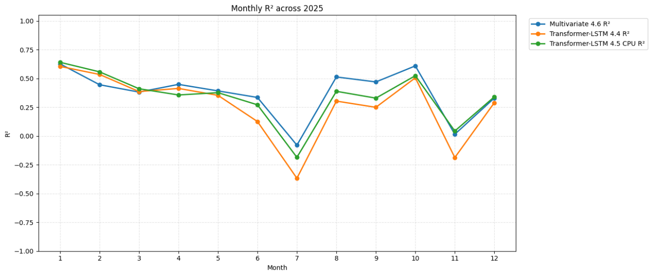
Figure 8: Monthly R² score across test set (2025)
For the R² [Fig. 8], the models display high consistency (R² = 0.4 - 0.65) across winter, spring, and early autumn. However, performance dips sharply during July and November. In these specific months, extremely low background PM_{2.5} variance combined with rapid seasonal atmospheric transitions causes univariate models to produce negative R² scores (performing worse than a mean baseline). Crucially, the Multivariate Transformer-LSTM mitigates these drops the best, maintaining superior stability in July (R² = -0.08 vs. -0.36 for univariate) and remaining positive in November (R² = 0.02 vs. -0.18). This highlights that explicit meteorological integration is essential for preserving predictive capability during non-winter transition periods.

4.7 Comparative Benchmarking against Zeng et al. (2026)
To contextualise the predictive performance of the primary forecasting backbone, the optimised Transformer-LSTM hybrid is evaluated against the target benchmark established by Zeng et al. (iScience, 2026).
Table 6: Methodological and Performance Comparison against Target Benchmark
Experimental Dimension | Zeng et al. (iScience, 2026) Benchmark | Present Study (Optimised Transformer-LSTM) | Comparative Assessment
Study Region | Chengdu Basin, China | Bath, Somerset, UK | Small-scale UK valley urban setting versus broad basin geography
Temporal Resolution | Daily aggregate predictions | Hourly continuous projections | Finer temporal resolution; captures micro-scale diurnal emission peaks.
Forecast Horizon | Multi-day daily horizons | 24-hour vector output (72h lookback) | Direct 24-step hourly forward prediction
Test Window Strategy | Discontinuous seasonal blocks | Continuous 1-month evaluation (Jan 2025) | Persistent winter inversions without seasonal isolation
Target Metric (R²) | R² = 0.62 | R² = 0.6469 | Comparable coefficient of determination (+0.0269 R²), obtained at finer temporal resolution in a different pollution regime
Error Magnitudes | Reported across daily aggregates | MAE = 2.72 μg/m³, RMSE = 3.83 μg/m³ | Sub-3 μg/m³ average deviation across peak winter pollution conditions

Achieving a comparable coefficient of determination (R² = 0.647 vs. R² = 0.62) at hourly resolution indicates that combining multi-head self-attention with recurrent LSTM smoothing effectively captures high-frequency urban atmospheric dynamics without requiring daily temporal smoothing.
Two caveats qualify this comparison. First, the mean observed concentration of the Bath January window is 9.33 μg/m³, substantially below concentrations typically recorded in the Chengdu Basin; since R² is defined relative to the variance of the local target series, equal coefficients of determination do not imply equal predictive difficulty. Second, hourly resolution is not necessarily more demanding than daily resolution in R² terms, because hourly autocorrelation is stronger and a larger share of target variance is consequently explainable from the autoregressive signal alone. The comparison should therefore be read as contextual positioning rather than as a like-for-like benchmark.

4.8 Model Context Protocol (MCP) Operationalisation
The Optimised Transformer-LSTM Hybrid was integrated into a live Model Context Protocol (MCP) server environment using FastMCP, providing an operational interface for automated decision support [Fig. 9].
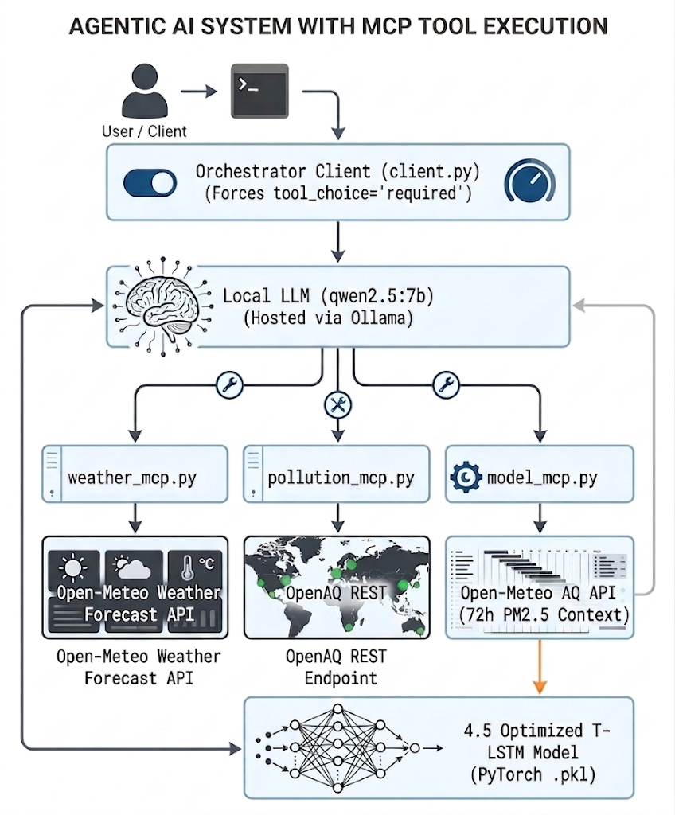
Figure 9: MCP Architecture and Tool Interaction
*End-to-End Model Context Protocol (MCP) Architecture and Tool Interaction Flow
The three MCP tools described in Section 3.6 were set up, with the forecasting tool confirmed to execute live inference from the saved model checkpoint against real-time Open-Meteo and OpenAQ data.
To ensure tool execution reliability, the orchestration client enforces tool usage for queries containing operational keywords such as weather, pollution, forecast, or outdoor planning. This constraint prevents the LLM from generating memory-based responses, directing it to answer directly from model predictions and live API payloads. Keyword enforcement was necessary because the deployed LLM, constrained by available memory, lacked sufficient instruction-following capacity to reliably invoke tools in response to implicitly phrased queries. A larger model would be expected to handle these cases without explicit keyword enforcement. Nonetheless this method and model served adequately as a proof-of-concept test of the end-to-end architecture.

Chapter 5: Discussion

5.1 Model Performance and Architectural Trade-offs
Of the architectures evaluated, the Optimised Transformer-LSTM Hybrid achieved the strongest performance across all three metrics simultaneously (R² = 0.647, MAE = 2.72 μg/m³, RMSE = 3.83 μg/m³). When evaluated on the same January 2025 window, standalone Transformer configurations produce higher MAE and higher RMSE than the hybrid, while the Base LSTM likewise trails the hybrid on both metrics. This is consistent with the proposed mechanism: multi-head attention supplies the long-range atmospheric context that a purely recurrent model tends to lose over a 72-hour lookback, while the downstream LSTM imposes a sequential inductive bias that stabilises transitions between consecutive forecast steps. Neither component achieves this in isolation.
Permutation importance confirms that PM_{2.5} autocorrelation is the dominant forecasting signal (ΔMAE = +0.36 μg/m³ when permuted), with wind speed and surface pressure forming a secondary tier of importance. This explains why the multivariate model (R² = 0.622) does not substantially outperform the optimised univariate model (R² = 0.647): at hourly resolution, yesterday's pollution already implicitly reflects yesterday's weather. The marginal benefit of explicit weather covariates is real but small when the backbone has already been fully optimised for the univariate task.

5.2 Physical Dynamics vs. Graph Topologies: Analysing the Spatio-Temporal model
Incorporating spatial road-network topology via the ST-GNN actively hurt model performance rather than improving it. Fusing the frozen spatial encoder from Stage 1 into the temporal backbone reduced predictive strength from R² = 0.599 (temporal ablation) to R² = 0.559 (full ST).
Three factors explain this outcome. First, Stage 1 was trained exclusively on summer and autumn traffic data, so its frozen weights encoded seasonal patterns that do not generalise to the winter test window (out-of-sample R² = -0.210). Second, in Bath's valley microclimate, PM_{2.5} concentrations are governed primarily by regional synoptic meteorology rather than localised traffic bottlenecks; the spatial signal the GNN was asked to encode is simply less dominant than the meteorological one. Third, Stage 1 had approximately 61,000 parameters trained on only around 5,500 samples, a ratio insufficient to prevent memorisation of the training distribution. These results are data-specific, not architectural: the two-stage design is conceptually sound, but would require a full-year, seasonally balanced traffic dataset to produce a useful spatial prior.
It is important to clarify these results do not constitute evidence that road-network topology is informationally irrelevant to PM_{2.5} dynamics in general. In settings with dense, multi-year, and seasonally balanced traffic sensor networks (as evaluated in the STGCN (Yu et al., 2017) and DCRNN (Li, Y et al. 2018)) spatial graph operations may provide meaningful predictive lift that the present experimental design was unable to test due to lack of depth in the dataset.

5.3 Multi-Seasonal Stability and Seasonal Transition Dynamics
The 12-month evaluation of the Multivariate Transformer-LSTM (R² = 0.602, MAE = 2.31 μg/m³ across 8,760 hourly timesteps) demonstrates the model's capacity to generalise across the full annual cycle. The lower mean absolute error observed (MAE = 2.31 μg/m³ versus 2.72 μg/m³ for the winter-only window) reflects the reduced background PM_{2.5} baseline during spring and summer months rather than a fundamental improvement in model accuracy.
The monthly decomposition reported in Section 4.6 qualifies this further: performance is not uniform across the annual cycle, and both configurations record negative R² in July and the univariate configuration also in November, months in which background PM_{2.5} variance is very low and R² becomes an unstable measure, the compressed July distribution visible in [Fig. 5] confirms this directly. The multivariate configuration nonetheless mitigates these episodes substantially (July: R² = -0.08 versus -0.36; November: R² = +0.02 versus -0.18), which supports retaining explicit meteorological inputs for year-round monitoring rather than for peak-winter accuracy alone. Seasonal robustness should therefore be understood as reduced degradation during low-variance transition months, not as uniform performance across the year.
The univariate optimised checkpoint remains preferred for lightweight operational deployment, given it requires only PM_{2.5} as input, reducing API dependency and inference latency.

5.4 Model Context Protocol (MCP) for Operational Health Decision Support
Translating numerical PM_{2.5} forecasts into public health guidance requires more than accurate predictions. It requires contextual reasoning about what a given concentration level means for a specific activity, location, and population group. By coupling live API integrations with model inference and enforcing mandatory tool execution, the system grounds the locally hosted LLM in real-world data.
This architecture is designed to reduce reliance on parametric memory, such that public health advisories, are traceable and verifiable with live data.
A notable constraint encountered during deployment was the tendency of the 7-billion parameter model to generate responses from parametric memory without invoking the available MCP tools, bypassing the grounding mechanism entirely. This behaviour is consistent with known limitations of small-scale instruction-tuned models in structured tool-calling tasks (Schick et al., 2023; Yao et al., 2023), where tool invocation competes with the model's default text generation prior. Enforcing tool usage on tool-relevant queries and implementing a retry nudge on non-compliant responses mitigated this issue in practice. However, formal evaluation of advisory accuracy was not conducted within the scope of this project and remains an essential step before any operational deployment. Calibration of model output against the council's physical street-level sensors is a further prerequisite, as the current forecast target is a city-scale reanalysis field rather than kerbside concentrations where pedestrian exposure is highest.

5.5 Limitations of the Study
Despite the competitive predictive performance of the forecasting backbone of the system, several limitations should be noted:
- Traffic Data Timeline Mismatch: The structural temporal gap between the 9.5-month traffic counter dataset (2017-2018) and the 9-year environmental reanalysis grid constrained the continuous training of spatio-temporal architectures.
- Reanalysis Data Reliance: the target series is a city-scale model field rather than a direct physical measurement; the methodological rationale and operational implications are discussed in Sections 3.2 and 5.4 respectively.
- Local LLM Context and Latency: Executing a quantised 7-billion parameter language model locally ensures data privacy and offline capability but introduces resource constraints and slight latency trade-offs during multi-tool chaining pipelines.
- Model Selection Stability: each configuration was retrained several times during development, and the relative ranking of architectures remained consistent across runs. Formal multi-seed reporting with paired significance testing was not conducted, so differences of the order of ΔR² ≈ 0.01 should be interpreted with corresponding caution.
- Baseline Scope: comparison is made against a naïve seasonal predictor and a standalone LSTM rather than against classical statistical or tree-based methods. The naïve baseline establishes the difficulty of the task itself, while the LSTM establishes what a conventional recurrent architecture achieves on the same data; ARIMA and gradient-boosting comparisons were judged to add limited discriminative value given this framing, but their omission means the advantage of deep learning over classical time-series methods is not quantified here.

5.6 Practical Implications and Future Research Work
This research offers practical applications for municipal planning and public health governance. Local authorities and event organisers can leverage the MCP decision-support pipeline to automate localised risk assessments, reducing exposure for vulnerable populations during acute air pollution events.
Beyond the immediate project scope, broader research avenues include:
- Remote Sensing Data: Incorporating high-resolution satellite Earth observation data (e.g., Sentinel-5P TROPOMI) to expand spatial coverage in regions lacking dense ground monitoring infrastructure.
- Controlled Hyperparameter Alignment: Applying equivalent Optuna-based hyperparameter tuning across both univariate and multivariate Transformer-LSTM baselines to isolate whether meteorological covariates yield statistically significant gains over pure PM_{2.5} autocorrelation at hourly resolution.

5.7 Ethical Considerations and System Governance
The following sections examine three governance dimensions relevant to this system: data privacy, algorithmic safety, and computational infrastructure. Operationalising a data-driven pipeline requires equal rigour in each.

5.7.1 Data Governance, Legal Bases, and Privacy-Preserving Minimisation
The multi-modal data pipeline developed in this study relies on heterogeneous municipal data streams, including Automatic Number Plate Recognition (ANPR) camera networks, Automatic Traffic Counters (ATC), and reanalysis air quality grids. While ambient meteorological and atmospheric reanalysis datasets represent non-personal physical measurements, traffic monitoring streams, specifically ANPR logs capturing vehicle movements, present critical data privacy considerations.
Under the United Kingdom General Data Protection Regulation (UK GDPR) and the Data Protection Act 2018 (DPA 2018), vehicle registration marks (VRMs) captured by ANPR networks constitute personal data. Given a registration plate uniquely identifies a motor vehicle, it functions as an indirect identifier that can be linked to an individual when combined with external vehicle licensing registries (such as the DVLA database). As the spatial encoder degraded performance (Section 4.4), the configuration selected for deployment uses no traffic data at all and therefore processes no personal data at inference time. This is incidental rather than intended, but it substantively limits the privacy exposure of the operational system.
Nonetheless raw ANPR streams comprising over 3.72 million individual transaction records were processed in a secure, isolated staging environment. Explicit vehicle identifiers (VRMs) and individual transaction timestamps were discarded, and the records were transformed into hourly vehicle counts per node. Individual movement trajectories were aggregated into hourly macroscopic volumetric flow counts, mean speed metrics (mph), and average segment travel times across the 24 spatial sensor nodes. Hourly aggregation eliminates the capacity to re-identify individual vehicle journeys or infer personal movement patterns, supporting compliance with the UK GDPR data minimisation principle while preserving the underlying physical traffic density signal required for spatio-temporal modelling.

5.7.2 Algorithmic Safety, Hallucination, and Unvalidated Health Advisory Risks
Integrating Large Language Models (LLMs) into public health decision-support systems introduces substantial safety and ethical risks, particularly regarding autonomous text generation, parametric hallucination, and unvalidated medical advice. While deep learning backbones generate precise numerical point forecasts (e.g., predicting an atmospheric PM_{2.5} concentration of 28.4 μg/m³), non-expert civic stakeholders and event planners require qualitative risk assessments. However, employing generative language models to bridge this interpretation gap creates systemic safety challenges if the language model generates incorrect or overly reassuring health guidance.
The primary risk is parametric hallucination: the tendency of autoregressive models to generate plausible but factually incorrect assertions from internal priors rather than ground-truth state data. The over-alerting and under-alerting carry asymmetric consequences. An advisory that understates exposure could lead to cardiovascular or respiratory harm for vulnerable populations undertaking strenuous outdoor activity, whereas a false alarm causes unnecessary cancellation. The evaluation metrics used in this study are symmetric and therefore provide no information about which direction of error dominates near a decision threshold.
To systematically mitigate these risks, the deployment architecture rejects end-to-end text generation from parametric memory. Instead, it enforces strict structural grounding through the Model Context Protocol (MCP) using FastMCP and a local qwen2.5:7b model runtime. By constraining the orchestration client to enforce mandatory tool execution, the language model is prohibited from responding to environmental queries using its internal memory alone. The LLM acts strictly as a structured reasoning agent and natural-language synthesiser: it must explicitly call predict_bath_pm25_forecast to obtain deterministic quantitative inference vectors from the PyTorch model checkpoint, alongside live observations from get_weather_bath and get_pollution_bath.
Furthermore, the system design enforces clear operational boundary limits. Generated outputs are strictly framed as advisory decision-support tools for municipal planners rather than clinical medical advice. Continuous forecasts are programmatically mapped to validated Air Quality Index (AQI) thresholds established by statutory bodies (WHO and UKHSA), providing a deterministic guardrail against arbitrary qualitative claims. Because small-scale quantised language models (7B parameters) can exhibit instruction-following drift or fail to invoke tools on complex phrasing, human-in-the-loop oversight remains a mandatory ethical requirement prior to public dissemination. This model is a testing system; it requires a thorough evaluation and potentially a larger or more capable LLM base to act as advisor for ideal recommendations, it is not a ready for deployment model.

5.7.3 Operational Infrastructure: Local Inference, Data Sovereignty, and Optimisation Carbon Footprint
The architectural decision to deploy the forecasting backbone and language model locally on Central Processing Unit (CPU) infrastructure rather than relying on commercial cloud APIs carries distinct ethical, economic, and environmental trade-offs.
Data Sovereignty and Zero Recurring Cost
Deploying the qwen2.5:7b LLM locally via the Ollama runtime and executing model inference on edge CPU hardware guarantees total data sovereignty. Unlike proprietary cloud-based LLM APIs (such as OpenAI GPT-4 or Anthropic Claude), where operational prompts and environmental queries are transmitted over external networks to third-party data centres, CPU-local processing ensures that all municipal sensor streams, local traffic states, and user interactions remain completely contained within the local authority infrastructure. This architecture eliminates third-party data exposure risks, ensures compliance with local government cybersecurity standards, and prevents operational lock-in. Furthermore, local CPU inference incurs zero recurring API token costs, enabling low-resource municipal councils to run continuous 24/7 environmental monitoring and advisory services indefinitely without budget constraints.
Energy Overhead and Carbon Footprint of Model Tuning
While edge inference provides economic and privacy benefits, the computational resource consumption during model development presents an environmental trade-off. Deep learning research contributes to carbon emissions through the energy-intensive training of neural architectures and automated hyperparameter tuning.
To optimise the Transformer-LSTM hybrid architecture, automated hyperparameter optimisation was executed using Optuna across approximately 40 evaluation trials per model family. Search parameters included multi-head attention hidden dimensions, LSTM layer depth, dropout rates, learning rates, and lookback window configurations. The hyperparameter optimisation workload across all model families required approximately 72 hours of multi-core GPU compute time on a local workstation platform.
Although this optimisation represents a modest but non-trivial environmental impact, this is modest relative to industrial-scale LLM pre-training. Additionally, the inclusion of hyperparameter optimisation is ethically justified by the resulting gains in model performance. The Optuna search yielded a +3.61 percentage-point increase in variance explained (R² improving from 0.611 to 0.647) and significantly reduced extreme prediction overshoots during peak pollution events. In environmental health forecasting, higher predictive accuracy directly translates to more reliable public risk mitigation, balancing the upfront computational carbon cost against long-term operational public health benefits.

Chapter 6: Conclusions

6.1 Summary of the Study
This dissertation set out to develop, evaluate, and operationalise a deep learning system for hourly PM_{2.5} forecasting in Bath, UK. Through progressive model development, a spatio-temporal exploration, and deployment through a Model Context Protocol advisory pipeline, the research produced both a performant forecasting backbone and a functional proof-of-concept for LLM-mediated environmental decision support.

6.2 Principal Findings
Within the set of configurations evaluated under a common January 2025 protocol, the Optimised Transformer-LSTM is the strongest performer on all three metrics simultaneously, achieving R² = 0.647, MAE = 2.72 μg/m³, and RMSE = 3.83 μg/m³. Both standalone Transformer and standalone LSTM configurations produce higher error on both MAE and RMSE, confirming that the recurrent smoothing stage improves step-to-step stability without sacrificing mean error performance.
Hyperparameter optimisation via Optuna delivers substantial and consistent gains. Automated search across approximately 40 trials per configuration contributed a +3.61 percentage-point improvement in R² over the unoptimised hybrid (from R² = 0.611 to R² = 0.647), confirming that architecture design and hyperparameter configuration are jointly necessary for competitive performance.
The evidence is consistent with, but does not establish, a dominant role for PM_{2.5} autocorrelation. A tuning-matched comparison is required before the marginal contribution of meteorological covariates can be quantified. Adding eight physical weather predictors to an already-optimised univariate model yields a marginal R² difference of -0.025. The univariate model offers superior accuracy on short evaluation windows; the multivariate model offers greater seasonal robustness and physical interpretability over extended horizons, maintaining R² = 0.602 across a full 12-month cycle.
The spatio-temporal transfer learning experiment produces informative results. Road-network topology, encoded from 9.5 months of seasonally skewed traffic data, actively degrades performance when the frozen spatial embeddings are introduced into the temporal backbone (R² falling from 0.599 to 0.559). The two-stage architecture is conceptually sound; the failure is attributable to insufficient and seasonally imbalanced traffic data rather than the approach itself.
The MCP advisory architecture demonstrates that quantitative forecasting can be operationalised for public health decision support. Connecting the trained model to a locally hosted LLM via structured tool-calling enables data-grounded advisories. The tool enforcement mechanism is identified as a necessary reliability constraint for small, quantised models in structured reasoning tasks.

6.3 Contribution to Knowledge
This study makes two explicit contributions. Methodologically, it demonstrates that PM_{2.5} forecasting at R² = 0.647 is achievable at hourly resolution in a UK valley city, under a more demanding continuous evaluation protocol than prior benchmarks, without requiring daily temporal aggregation or spatial graph operations. Applied, it provides a working end-to-end pipeline connecting a trained environmental forecasting model to an LLM-based advisory system via the Model Context Protocol. Ullah et al. (2026) demonstrate that integrating a forecasting model with a rule-based recommender can automate advisory generation; however, their system relies on pre-programmed ecological response rules rather than a language model capable of contextual reasoning from live API data. No study has connected a trained environmental forecasting backbone to an LLM via a standardised tool-calling protocol (MCP) for dynamic public health advisory generation.

6.4 Limitations
Additional constraints apply beyond those discussed in Section 5.5. The primary benchmark evaluation covers only January 2025, matching the Zeng et al. (2026) benchmark period and leaving the seasonal performance of the optimised univariate model outside this window uncharacterised. Although the 12-month multivariate evaluation provides broader temporal coverage, it does not establish equivalent seasonal performance for the optimised univariate backbone. The MCP advisory pipeline has not been formally evaluated against domain-expert judgement; consequently, the quality and safety of LLM-generated public health advisories remain unverified. Furthermore, as the prediction target is a spatially smoothed reanalysis field rather than a direct physical measurement, reported metrics may be optimistic relative to performance against independent street-level sensors. The study is geographically constrained to a single UK valley city, and the generalisability of the architecture and findings to coastal, flat, or denser urban environments remains untested. These constraints define the scope within which the findings should be interpreted and indicate the principal priorities for further validation. Lastly, the forecasts are point estimates; prediction intervals are not provided. Quantile loss, MC dropout, or conformal prediction would be required for risk-calibrated advisories.

6.5 Recommendations and Future Work
Based on the findings and limitations of this study, four key directions are recommended for future research:
- Operational AQI Integration and Expert Evaluation: Completing AQI band mapping within the MCP pipeline to trigger UKHSA/WHO advisory tiers, paired with formal human evaluation of LLM-generated advisories against domain-expert recommendations.
- Seasonally Balanced Transfer Learning: Collecting a full-year traffic dataset to re-evaluate spatio-temporal transfer learning using a reduced Stage 1 model capacity to prevent overfitting.
- Direct Boundary-Layer Dynamics: Explicitly ingesting Planetary Boundary Layer Height (PBLH) vectors into the multivariate feature space to model thermal inversion depth directly rather than relying on surface pressure proxies.
- Topographical Generalisability: Applying the Transformer-LSTM backbone and MCP framework to cities with contrasting topographies (e.g., coastal zones or flat basins) to evaluate generalisability beyond the Bath valley case study.

6.6 Closing Statement
This research demonstrates that reliable hourly PM_{2.5} forecasting at R² = 0.647 is achievable in a UK urban valley setting, achieving a coefficient of determination comparable to that reported by Zeng et al. (2026) in a different urban setting and at finer temporal resolution. The 12-month extended evaluation further confirms that the multivariate configuration maintains robustness across the full annual cycle, including the more volatile spring and autumn transition periods. The path from a trained research model to a live environmental advisory system is viable through Model Context Protocol integration, even where the spatio-temporal extension failed under the available data constraints. The negative result from that experiment is informative in its own right: it establishes that high-resolution meteorological covariates are sufficient for hourly urban PM_{2.5} forecasting in Bath, and that spatial graph operations require substantially richer and more seasonally balanced traffic data before they can contribute meaningfully. Together, these findings provide a reproducible and extensible foundation for operational environmental health decision support in UK municipal planning contexts.

References
Anthropic (2024) Model Context Protocol. Available at: https://www.anthropic.com/news/model-context-protocol (Accessed: 18 June 2026).
Ariuntugs, B. and Maduranga, K.D.G. (2025) 'KriGNN: A Hybrid Kriging and Graph Neural Network Framework for Spatio-Temporal Air Pollution Forecasting', in 2025 IEEE International Conference on Data Mining Workshops (ICDMW). Available at: https://ieeexplore.ieee.org/document/11415914 (Accessed: 22 June 2026).
Carslaw, D.C. and Rhys-Tyler, G. (2013) 'Trends in NOx and NO₂ emissions from road traffic in Great Britain', Atmospheric Environment, 81, pp. 339-351. (Accessed: 1 June 2026)
Clarity (2023a) Clean air cities: Innovative approaches to improving air quality in urban settings. Available at: https://www.clarity.io/blog/clean-air-cities-innovative-approaches-to-improving-air-quality-in-urban-settings (Accessed: 12 June 2026).
Clarity (2023b) Main causes of air pollution in big cities. Available at: https://www.clarity.io/blog/main-causes-of-air-pollution-in-big-cities (Accessed: 12 June 2026).
DEFRA (2024) UK Air Quality Data Archive. Department for Environment, Food & Rural Affairs. Available at: https://uk-air.defra.gov.uk/ (Accessed: 5 June 2026).
Fan, H., Zhao, C., Yang, Y. and Yang, X. (2021) 'Spatio-Temporal Variations of the PM2.5/PM10 Ratios and Its Application to Air Pollution Type Classification in China', Frontiers in Environmental Science, 9, p. 692440. doi:10.3389/fenvs.2021.692440.
Kaleta, D. and Kozielska, B. (2023) 'Spatial and Temporal Volatility of PM2.5, PM10 and PM10-Bound B[a]P Concentrations and Assessment of the Exposure of the Population of Silesia in 2018-2021', International Journal of Environmental Research and Public Health, 20(1), p. 138. doi:10.3390/ijerph20010138. (Accessed: 15 July 2026)
Kunak (2024) Urban air pollution: Causes and impacts. Available at: https://kunakair.com/urban-air-pollution/ (Accessed: 5 June 2026).
Lee, Y. and Kang, Y. (2025) 'Peak-GraphTFT: A GCN-Augmented Temporal Fusion Transformer with Peak-Sensitive Learning for Predicting Pedestrian Congestion in Shadow Areas'. Available at: https://dl.acm.org/doi/pdf/10.1145/3764912.3770814 (Accessed: 8 July 2026).
Liang, B., Bai, H., Bai, D. and Liu, X. (2022) 'Emissions of non-methane hydrocarbons and typical volatile organic compounds from various grate-firing coal furnaces', Atmospheric Pollution Research, 13(4), p. 101380. doi:10.1016/j.apr.2022.101380. (Accessed: 15 July 2026)
Lim, B., Arık, S.Ö., Loeff, N. and Pfister, T. (2019) 'Temporal Fusion Transformers for interpretable multi-horizon time series forecasting', arXiv. Available at: https://arxiv.org/pdf/1912.09363 (Accessed: 10 June 2026).
Li, Y., Yu, R., Shahabi, C. and Liu, Y. (2018) 'Diffusion Convolutional Recurrent Neural Network: Data-Driven Traffic Forecasting', arXiv. Available at: https://arxiv.org/abs/1707.01926 (Accessed: 28 July 2026).
Lynch, S.T., Derakhshan, P. and Lynch, S. (2025) 'A Novel Hybrid Temporal Fusion Transformer Graph Neural Network Model for Stock Market Prediction', AppliedMath, 5(4), p. 176. doi:10.3390/appliedmath5040176. (Accessed: 10 June 2026)
Manufact (n.d.) Manufact Platform. Available at: https://manufact.com/ (Accessed: 25 May 2026).
Met Office (2024) UK meteorological data. Met Office, UK. Available at: https://www.metoffice.gov.uk/ (Accessed: 5 June 2026).
Open-Meteo (2024) Weather and air quality API. Available at: https://open-meteo.com/ (Accessed: 1 June 2026).
Panja, M., Chakraborty, T., Biswas, A. and Deb, S. (2024) 'E-STGCN: extreme spatio-temporal graph convolutional networks for air quality forecasting', HAL Open Science. Available at: https://hal.science/hal-05524589 (Accessed: 10 June 2026).
Rath, S. and P, M. (2025) 'Air Pollution Forecasting Using Machine Learning with Temporal Fusion Transformer and Graph Neural Networks', IEEE Xplore. Available at: https://ieeexplore.ieee.org/abstract/document/10914714 (Accessed: 8 July 2026).
Schick, T., Dwivedi-Yu, J., Dessì, R., Raileanu, R., Lomeli, M., Zettlemoyer, L., Cancedda, N. and Scialom, T. (2023) 'Toolformer: Language models can teach themselves to use tools', arXiv. Available at: https://arxiv.org/abs/2302.04761 (Accessed: 5 June 2026).
UK Health Security Agency (UKHSA) (2023) Air pollution: Health effects and local authority guidance. London: UKHSA. (Accessed: 5 June 2026)
Ullah, A., Ejaz, H., Seher, E. and Kareem, Y. (2026) 'Real time air quality monitoring and forecasting using AI and nature-based recommender system for climate-resilient air quality management', Fusion Journal of Engineering and Sciences. Available at: https://fusionesj.com/index.php/fjes/article/view/101 (Accessed: 8 July 2026).
World Health Organization (WHO) (2021) WHO global air quality guidelines: Particulate matter (PM2.5 and PM10), ozone, nitrogen dioxide, sulfur dioxide and carbon monoxide. Geneva: WHO. (Accessed: 5 June 2026)
Yao, S., Zhao, J., Yu, D., Du, N., Shafran, I., Narasimhan, K. and Cao, Y. (2023) 'ReAct: Synergizing reasoning and acting in language models', arXiv. Available at: https://arxiv.org/abs/2210.03629 (Accessed: 15 July 2026).
Yu, B., Yin, H. and Zhu, Z. (2017) 'Spatio-temporal graph convolutional networks: A deep learning framework for traffic forecasting', arXiv. Available at: https://arxiv.org/abs/1709.04875 (Accessed: 10 June 2026).
Zeng, L., Dong, R., Yuan, M., Jing, L. and Jiao, S. (2026) 'Evaluating deep learning time series models for PM2.5 forecasting across diverse horizons', iScience, 29(2), p. 114770. doi:10.1016/j.isci.2026.114770. (Accessed: 8 July 2026)

Appendices
Generative AI tools, primarily Claude (Anthropic), were used during the preparation of this dissertation as an assistive tool in accordance with the University of Bath Type B GenAI guidance.
AI assistance was used for the following purposes: grammar and spelling checking, structural feedback on chapter organisation and paragraph ordering, suggestions for rephrasing overly complex or unclear sentences, and feedback on academic tone and consistency. All these were suggestions which were then reviewed and rewritten.
AI was not used for the following: the original research design, data collection, model development, experimental implementation, interpretation of results, or the drawing of conclusions. All quantitative results, architectural decisions, and critical judgements presented in this dissertation reflect my own work. All AI-generated text was reviewed and edited before inclusion, and I take full responsibility for the final content.

